**HUMAN COMPUTER INTERACTION**

**BY**

**HARUNA NUHU**

**ST/CS/ND/19/015**

**BEING A SEMINAR PAPER**

**PRESENTED TO THE DEPARTMENT OF COMPUTER SCIENCE**

**SCHOOL OF SCIENCE AND TECHNOLOGY**

**FEDERAL POLYTECHNIC, MUBI ADAMAWA STATE**

**DECEMBER, 2021**

**Abstract**

*The improvements in the development of computer technology has contributed to the concept of the Human Computer Interactions (HCI) since the computer systems has the interfaces which can easily be used by humans. The mental models show the way different users perceive how the computer systems behave in solving the problems in the environment. The young educated and knowledgeable individuals have been able to carry out research on the developments of computer systems and the success of the human computer interfaces for mental models. The human computer interfaces are designed in such a way that they are connected the user’s mental models thus providing them with the easier execution of work. In this paper the mental model in Human computer interface will be discussed.*

**Introduction**

The study of Human-Computer Interaction (HCI) is the study of ‘usability’; that is the study of the user’s experience with the computer (Carroll & Olson, 2018). Various theories offer explanations on the evolution of HCI as noted by Bannon (2009); these range from an academic perspective, business perceptions or even that of the everyday user. With the introduction of the internet, in today’s economy and learning, the world has become a global village; where information sharing can be moved around the world for little or no cost, Samuel and Adeniyi (2015). With the help of a better understanding of humans and how they interact with computers, developers have been able to find a centre to strike a balance in producing what they perceive the computer users need to make their computer interaction easier.

Hewett (2012) defined Human-Computer Interaction (HCI) as a discipline concerned with the design, implementation, and evaluation of an interactive computing system for human use and for studying the major phenomena surrounding them. Also, HCI can be defined as an experience an individual acquires when that individual comes in contact with a computer system. It is an independent discipline which strives to improve the quality of interaction humans have with computers. As the computer has become a critical part of our everyday society, it is, therefore, important to ensure that users have an excellent experience. So many principles have been created to guide computer developers in producing user-friendly systems; HCI has had an opportunity to play a role in providing and influencing user’s experience – irrespective of the operating environments. In this study, we would be looking at the influence HCI has on Higher Education and why it is necessary to promote its importance in a learning environment.

Human Computer Interaction (HCI) refers to the process and the study of designing different computer interfaces and determining their usability by keeping the mental of the anticipated user in mind (Carroll & Olson, 2018). It therefore creates a strong relationship between the computer and the human beings, the mutual understandings of the humans and the creation of the computer system software which will simplify the work of the user on such systems of the computers, boosting the morale of the humans to use the interface and should be able to boost their ability to use the computer interfaces designed. The human computer interaction consists of three parts derived from the name, that is, the human, computer and the interaction. HCI contributes to the sketching of the fidelity on both the low and the high ends which gives it the ability to respond to the feedback of the users and interprets the feedback fed into the system by the user. This focuses on the mental models in the HCI and the advantages and the disadvantages of the human computer interfaces design in mental models. In this paper, the human computer interaction parts will also be discussed and also the different approaches which may be used to design the HCI.

# Evolution

As technology advances, the requirements of computer users are more demanding, the evolving nature of user requirements is reflected in the multiple tasks that can be performed by devices today e.g. voice control, touch screen devices and many more. According to Grudin (2012), the evolution of HCI from an academic standpoint was a revolution, using the innovation of libraries in the USA as an example and contrasting the effect of this innovation with its European counterpart. He argued that the needs of the users were a catalyst to the evolution and HCI evolution varied in different countries according to their needs. Undoubtedly, HCI advancement is bound to impact different aspects of human life; the society in general, business, and the learning environment (Rosson, 2012); where productivity and efficiency of each user, employee or student are profitable and resourceful (Zhang, 2006).

## Structure of HCI

HCI, as the name suggests, comprises three major parts within the framework: the user, the computer, and the interaction, indicates the ways they work together to achieve goals. Figure 1 shows three main components of human computer interaction.

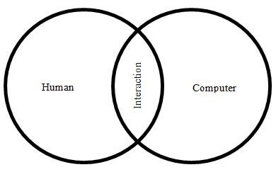

**Figure 1:** Three components of HCI

**a) Humans**

The products of the human computer interface are produced by the designers to be consumed or be used by the humans which comprises the major users of the interface for the execution of the simple tasks on the computer. This is focused on studying and understanding the humans in the way they react to the computer systems to process their information, their communication, and to determine and detect the characteristics as well as the behavior of the human beings as the user who processes the information, that is, through the learning, attention and the use of the motor skills as well as displaying the problem solving techniques and generating the different models for the study (Nardi, 2016).

**b) Computers**

Computers are designed and fitted with different components which gives it the ability to interact with the user and provide the desired feedback which satisfies the needs of the user. Computers allow the user to interact with these components for their formulation and the provision of an effective mobility and learning. The characteristics and uses of the computers such as the ability to process data faster, provide formulations and carry out repetitive commands and actions makes it appealing to the user and thus enables the user to produce high quality output (Baecker, 2014).

**c) Interaction**

The interaction between the computer and humans is what contributes much in the production of an effective and high quality output and not the level of the skills which the user has acquired in the use of the computers, this means that the interaction is a two - way process in the formulation of different tasks in the computer interfaces. Figure 1 below illustrates the development process of the Human Computer interface (Preece *et al.,* 2014).

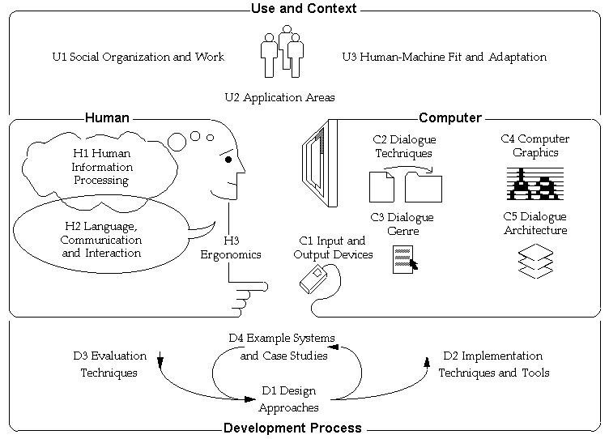

Figure 2: Human Computer Interaction development process (Preece, et al., 2014).

**Advantages and Limitations of Human Computer InterACTION**

Ever since the release of the first personal computers, technology has made its way into the lives of the common man. The acceptability has been boosted with the help of HCI. As the systems started to become more user-friendly, the demand has been on the rise. Not only has the personal uses but also f industrial purposes been synchronized with the technology, because of HCI’s development. It can be observed from report of Musunuru (2020), that humankind is going through a paradigm shift in terms of technological advancements. Almost all the work done today is done with the help of computers. By improving the way, a human interacts with a computer, HCI has provided the much need boost to the technology. All of the major technical domains are using computers, and with HCI constantly developing, many critical advancements can be observed in these domains. Some of the main field benefitting by HCI’s development are:

1. Entertainment industry
2. Bio-medical sciences
3. Smartphone industry
4. Health and fitness industry
5. Robotics
6. Security monitoring

The positive impact of HCI on the world of computational technology can be clearly understood with these examples. By making many day-to-day tasks easier and creating a user-friendly atmosphere, HCI has improved the quality of life over the years (Dix, 2017).

On the other hand, it has increased the reliability of machines. Another issue associated with HCI is that it refers to one specific mode of interaction and over-look the other. The need for training the user on these modes of interaction can always pose a challenge, which requires the user to start learning from scratch and hamper the old experience. The selection of the most suitable mode of interaction is a critical aspect of development. All possible modes of interaction might have limits in terms of user capabilities. For example, according to Van and Melguizo (2002), challenges associated with hand gesture specialized inputs, it requires the user to be in a specific position and also to follow certain motions specified in the program. The quantification of factors like enjoyment and emotional gain has always been a challenge. The positive impact of HCI outperforms the limitations on a grand scale. The human-computer interface is considered to be a source for a significant number of future advancements in technological fields (Van & Melguizo, 2002).

**Conclusion**

In conclusion, it can be said that HCI has impacted the learning environment as it has impacted other corresponding environments. The impact HCI has in the learning environment has been positive, however, the downside to it was that it created room for individuals to depend on it. The positive side to this phenomenon is that becoming familiar with all HCI concepts and appreciating them, improves a user’s interaction and this brings about efficiency. As well as, room for more innovative computer related ideas to make computer systems better for the future or even ideas, innovations or new discipline to support the HCI discipline. Furthermore, there is a significant difference between those who know HCI and appreciate it and those who don’t, and this as a result of either the background of the individual or the faculty in which they study. The difference can also be associated with how the students/staff and administrators perceive the role of HCI in their learning/teaching process.

# Recommendations

The first recommendation is that since it has been established that computer reduces drudgery and improve learning outcomes, HCI related courses should be introduced not only for the computer and science-related courses but also for every academic pursuit.

Secondly, as every discipline has its style of reasoning so systems developed for the different organizations should consider that in designing to make the system more user-friendly.

Finally, it will be interesting; in the nearest future, that an investigation is carried out on the degree of efficiency HCI has impacted in a learning environment. This is because of its benefits to them (students and staff) so that they are flexible and easily adapt without any substantial amount of interruption to their learning.

**REFERENCE**

Baecker, R. (2014). *Readings in Human Computer Interaction: toward the year 2000*. Elsevier.

Bannon, G. (2009). March. Human-computer interaction: process and principles of human computer interface design. *In 2009 International Conference on Computer and Automation Engineering* (230-233). IEEE.

Carroll, J. & Olson, J. (2018). Mental models in human-computer interaction. In *Handbook of human-computer interaction* (45-65). North Holland.

Dix, A. (2017). Human–computer interaction, foundations and new paradigms. *Journal of Visual Languages & Computing*, *42*, 122-134.

Grudin, K. (2012). Applied mental models in human–computer interaction. *Mental models in cognitive science: Essays in honour of Phil Johnson-Laird*, 223.

Hewwtt, P. (2012). High-fidelity prototyping of interactive systems can be formal too. In *International Conference on Human-Computer Interaction* (667-676). Springer, Berlin, Heidelberg.

Musunuru, G. (2020). The Opportunities and Limitations of Human Computer Interaction in Virtual and Augmented Reality. *International Journal of Computing, 2 (9),* 78-98.

Nardi, B. (2016). *Context and consciousness: activity theory and human-computer interaction*. Mit Press.

Preece, J., Rogers, Y., Sharp, H., Benyon, D., Holland, S. & Carey, T. (2014). *Human-computer interaction*. Addison-Wesley Longman Ltd.

Rosson, A. (2012). Mental models: concepts for human-computer interaction research. *International Journal of Man-machine studies*, *38*(4), 587-605.

Samuel, J. & Adeniyi, S. (2015). Low vs. high-fidelity prototyping debate. *interactions*, *3*(1), 76-85.

Van, G. & Melguizo, M. (2002). Mental models. In *The human computer interaction handbook: Fundamentals, evolving technologies and emerging applications* (52-80).

Zhang, V. (2006). Paper prototyping-what is it good for? A comparison of paper-and computer-based low fidelity prototyping. In *CHI'03 extended abstracts on Human factors in computing systems* (778-779).